Summary of Annual Condition
This section of the annual report provides an assessment of the condition of the region’s environment and a reflection on the likely impact of annual scale actions, events and observed change within the previous year, and over the previous three years. A key purpose of monitoring changes in the operating context is to help identify opportunities for adapting and changing the way we manage the environment.

The report is structured in line with the state-wide outcome framework that links the regional outcomes sought by catchment communities, to the high-level policy outcomes of the Victorian and Australian Government. These are outlined in each Regional Catchment Strategy (rcs.vic.gov.au).

How to interpret this report
The condition assessment for each theme describes the level of confidence or concern that catchment managers have in the future of the regional environment.

The assessment is based on a set of state-wide indicators outlined in the RCS outcomes framework, augmented with regionally specific indicators which have been selected based on criteria including availability and quality of data, and the linkages back to regional and policy outcomes.

As much as possible the reporting format attempts to provide a transparent path between the evidence and the assessment. It is not a definitive assessment but an assessment at a point in time based on the best available evidence.
TREND# RATING | DESCRIPTION
Positive | The indicator is moving in a positive direction and is expected to have a positive impact.
Neutral | The indicator is a neutral state, where movements may be significant but are within expected variation and will have little impact.
Concerned | The indicator is moving in a negative direction and is expected to have a detrimental impact.
Unknown | The trend is unknown.

#The trend is the change over time in the indicator, which could be an environmental asset, a pressure or a management activity. The trend is assessed against the direction required to contribute to the achievement of regional outcomes.
CONDITION* RATING | DESCRIPTION
Good | The condition is classified as good.
Moderate | The condition is classified as moderate.
Poor | The condition is classified as poor.
Not applicable | A condition rating is not applicable for this indicator
Unknown | The condition for this indicator is not known and or assessable

*Condition - where appropriate, a condition rating is provided that is based on the is the current state of the theme. A condition rating is based on assessments of the assets, pressures and management activities represented by the theme. The assessment is based on available science and expert advice as well as evidence gained during the preceding year.

Regional catchment condition and management summary

THEME | TREND # |  | CONDITION* | SUMMARY COMMENT
THEME | 2022-23 | OVER LAST  5 YEARS
Water | Neutral | Neutral | Moderate | The condition and management rating for water is moderate. Six key indicators that show a mix of trends have been used to determine a five-year rolling trend of neutral. The wet conditions and reasonably high rainfall led to a positive annual trend for river inflows. Environmental water flow compliance, water quality parameters, extent of protected or improved riparian land, and ground water indicators all show a neutral annual trend. The rolling five-year trend across the indicators are largely neutral, with a concerned trend for extent of wetlands.  Historical clearing of riparian vegetation, stock access, weed infestations, extraction and instream barriers, along with the growing impacts of climate change, continue to impact water quality, flow, and riverine health particularly in the upper catchments of the Barwon, Moorabool, Leigh and Curdies Rivers.
Land | Neutral | Concerned | Moderate | The condition and management rating for land is moderate. Four key indicators that show a mix of trends have been used to determine a five-year rolling trend of concerned. 22/23 was a relatively wet year, continuing a period of higher-than-average rainfall, this leads to a neutral annual trend in exposed soil, and positive annual trend in rainfall. The rolling five-year trend across the indicators shows a mix of results, with a concerned trend in both exposed soil and land use change over time, neutral trend in rainfall, and positive trend in agricultural commodities.  Programs supporting sustainable agricultural practices and land stewardship continue to engage with property owners across the region, however the long-term trends in land use change particularly significant increases in dry land cropping and decreases in native vegetation are significant challenges to land health.
Coast | Neutral | Neutral | Moderate | The condition and management rating for community is moderate. Two key indicators have been used to determine a rolling five-year trend of neutral. There is positive trend in area of salt marsh protection and neutral trend in estuarine water quality leading to a neutral annual trend.  While there are management practices in place and estuary water quality was stable and there was an increase in saltmarsh, the coasts and estuaries of the region face significant challenges associated with the threats posed by climate change as well as population, land-use and developmental pressures on the natural values of these assets. Critical water health issues (acidity, stormwater inflows, and cyanobacteria blooms) persist in several estuaries in the region.
Biodiversity | Neutral | Neutral | Poor | The condition and management rating for biodiversity is poor. Four key indicators have been used to determine a rolling five-year trend of concerned. There has been notable increase in area of pest predator and herbivore control and weed control. No notable change has been observed in the extent of native vegetation or the area of permanent protection in the region- leading to a neutral annual trend.  Species decline is still a critical challenge facing biodiversity in the Corangamite Region predominantly due to pressures such as introduced animal and plant species and land clearing being exacerbated by the increasing trends of urban encroachment, habitat fragmentation, climate variability and the spread of invasive species and diseases. Whilst there is a positive trend in the extent of management interventions being delivered, there currently isn’t the ability to clearly determine the impact this is having on the feral animal populations in the region. The extent of interventions is still very minor in comparison to the extent of the problem.
Community | Positive | Positive | Good | The condition and management rating for community is good. Four key indicators have been used to show a positive annual and positive rolling five-year trend. There has been an increase in both Traditional Owner partnerships and total number of Catchment Partnerships Agreement members. The total number of partnerships continues to increase in number compared to last year. The Landcare health survey continues to reflect that most groups in the Corangamite region are moving forward or above. Citizen Science volunteer numbers have increased this year after a decline over the past five years (largely due to COVID restrictions).

WATER Condition and Management Rating - Moderate
The condition and management rating for water is moderate. Six key indicators that show a mix of trends have been used to determine a five-year rolling trend of neutral. The wet conditions and reasonably high rainfall led to a positive annual trend for river inflows. Environmental water flow compliance, water quality parameters, extent of protected or improved riparian land, and ground water indicators all show a neutral annual trend. The rolling five-year trend across the indicators are largely neutral, with a concerned trend for extent of wetlands.
Historical clearing of riparian vegetation, stock access, weed infestations, extraction and instream barriers, along with the growing impacts of climate change, continue to impact water quality, flow, and riverine health particularly in the upper catchments of the Barwon, Moorabool, Leigh and Curdies Rivers.
Rationale for assessment:
- Investment has continued to enhance waterways through riparian and in-stream management and actions were completed at existing contracted projects. New incentive programs have been delivered across priority waterways in the region.
- Landowners who are unable or unwilling to participate in waterway management programs require targeted engagement approaches, tailored approach to riparian protection in the upper Barwon River is proving to be successful in securing project sites.
- Two formal river environmental water entitlements in the region are below what is recommended in FLOWS studies for the Moorabool and the Barwon, the CMA has been successful in using the limited formal entitlements as effectively as possible to achieve environmental flow outcomes
- The CMA has been an active participant in the Central and Gippsland Region Sustainable Water Strategy (CGRSWS) process pursuing opportunities to secure additional water for cultural and environmental priorities.
- The wetting and drying regime in the Lower Barwon Wetlands is required to maintain the environmental character of the wetlands. This is adaptively managed where possible to accommodate shared benefits with user groups.
- Water quality results presented a mix of responses, with some parts of the region more favourable than others. This is reflective of both landscape (e.g. high velocity streams), land use and the Victorian Environment Reference Standards (ERS) guidelines. Results are an improvement on previous years with a higher number of waterways meeting the ERS objectives, largely due to increase river inflows.
- Historical clearing of riparian vegetation, stock access, weed infestations, extraction and instream barriers continue to impact water quality, flow, and riverine health particularly in the upper catchments of the Barwon, Moorabool, Leigh and Curdies Rivers, along with the growing impacts of climate change.

Waterway indicators used in the assessment

Extent of protected or improved riparian land
The indicator reflects efforts to protect or improve the condition of riparian lands, including fencing, weed control, and revegetation and pest control (e.g. rabbits).

A range of activities delivered by the community and agencies contribute to habitat improvement and long-term improvements in the condition of waterways. Activities such as fencing and troughs for off-stream watering, revegetation and weed control, all support improved riparian and aquatic habitat and waterway condition.

Table below provides a summary of waterway and habitat improvement activities that were supported by Corangamite CMA in partnership with community and other stakeholders, between 2017-18 and 2022-23 in riparian areas and waterways.

Outputs/Year |  | 2017-18 | 2018-19 | 2019-20 | 2020-21 | 2021-22 | 2022-23
Structural Works | Fence (km) | 25 | 46 | 41 | 16 | 2 | 31
 | Water Storage - trough (no.) | 1 | 20 | 7 | 3 | 0 | 6
 | Waterway Structure (no.) | 20 | 32 | 43 | 35 | 13 | 14
Environmental Works | Vegetation (ha) | 168 | 97 | 507 | 295 | 97 | 157
 | Weed Control (ha)* | 596 | 1167 | 883 | 987 | 317 | 459
Planning and Regulation | Management Agreement (no.) | 45 | 64 | 37 | 18 | 46 | 45

* Weed Control is reported as an estimate of percentage of actual on ground hectares treated within the larger project site area.

Source Corangamite CMA

2022-23 assessment - TREND Neutral | Rolling five year assessment - TREND Neutral

River Inflows
This indicator provides estimates of river inflows in Corangamite Region
2022 was a wet year largely due to La Nina influences across the Corangamite catchment. This wet year follows a number of years with higher-than-average rainfall.

Long-term trends are showing a moderate increasing trend in river flows in the major river systems in the Corangamite region. The region typically experiences greater increases in rainfall and consequently river inflows in the southern areas, centered around the wetter Otway basin. The northern catchments are typically much drier.

Source Australia's Environment Explorer (ausenv.online)
https://www.ausenv.online/aer_pdf/2022/NRM_Regions_2017/Corangamite.pdf

2022-23 assessment - TREND Positive | Rolling five year assessment - TREND Neutral

Extent of wetlands
This indicator provides estimates of the overall rate of change in the extent and spatial distribution of wetlands and associated vegetation on public and private land in the Corangamite region.
The Corangamite region hosts significant areas of wetland habitats, including the internationally significant RAMSAR listed Western District Lakes and Lake Connewarre complex. Past water management, planning decisions, and agricultural drainage have changed the course and flow of waterways and resulted in the loss of naturally occurring ephemeral wetlands.

More recently there is increasing pressure on wetlands from encroachment through agricultural and urban development which reduces the condition of these areas. Climate Change is also a major threatening factor for wetlands in the region.

Perennial wetland cover has decreased by 23% from the 1989-90 baseline, and seasonal wetlands have decreased by 15% over the same period. Saltmarsh cover has decreased by 7%

Source- Victorian Land Cover Time Series (DEECA)

2022-23 assessment - TREND N/A | Rolling five year assessment - TREND Concerned

Groundwater resources
This indicator provides information on groundwater resources in the Corangamite Region.
The stability or decline of groundwater systems depends on the amount of water recharging the system and on how much water is being used.

The following table summarises the general trends in groundwater levels in Corangamite Region, based on analysis of the State Observation Bore Network (SOBN) for the Victorian Water Accounts annual reports 2014-19.

The wet season in 2022 has had a positive impact on the regions ground water catchments with the 5 and 10 year trends across all catchments being stable or rising.

Groundwater level trends Jan-March | Bungaree ground water catchment | Cardigan ground water catchment | Colongulac ground water catchment | Gellibrand ground water catchment | Gerangamete ground water catchment | Warrion ground water catchment
JAN-MAR_2018_5yr | declining | declining | rising | stable | stable | rising
JAN-MAR_2018_10yr | rising | rising | stable | declining | declining | rising
JAN-MAR_2019_5yr | declining | declining | stable | stable | declining | stable
JAN-MAR_2019_10yr | stable | rising | stable | stable | rising | rising
JAN-MAR_2020_5yr | stable | stable | stable | stable | stable | stable
JAN-MAR_2020_10yr | stable | rising | stable | stable | declining | rising
JAN-MAR_2021_5yr | rising | rising | rising | stable | stable | rising
JAN-MAR_2021_10yr | declining | rising | stable | stable | declining | stable
JAN-MAR_2022_5yr | rising | rising | stable | stable | rising | stable
JAN-MAR_2022_10yr | rising | stable | stable | stable | rising | stable

Source- Southern Rural Water
2022-23 assessment - TREND Neutral | Rolling five year assessment - TREND Neutral

Flow Compliance
This indicator considers compliance against flow regimes is based on separate downstream compliance sites for the Moorabool and Upper Barwon, with flow attained, compared to desired summer and winter flow regimes. The Lower Barwon wetlands is based on an agreed wetting and drying regime for the two wetland systems. The narratives below provide a summary of what has been experienced for each of the systems

While some flow components were met naturally for the upper Barwon entitlement, low flows in the dry season west branch were not met. If you look at the 'Hydrological Achievement' graphs in the current Seasonal Watering Plans show the following ratings
- Moorabool positive,
- Upper Barwon majority neutral,
- Lower Barwon - Reedy negative and Hospital Swaps neutral.

Flow compliance over 2022-23
Moorabool flow compliance
Another wet year resulted in a spill from Lal Lal reservoir that lasted for several months, which did not cease until late December 2022. All 2022 (as this excludes June 2023) winter/spring priority watering actions were met naturally due to the spill. This allowed all recommended environmental water releases to be made during summer and autumn, achieving full compliance for the summer/autumn season and the entire water year.

Upper Barwon flow compliance
During the dry period, the east branch low flow watering action was met naturally through a wet summer. One of two recommended dry period freshes was also achieved naturally in the east branch. The dry period low flow watering action was met in the west branch for all the dry period except for a short period over the new year due to an avulsion that diverted flows away from the main river channel. During this time, there were no environmental water releases down the west branch. Environmental water releases resumed at the end of January after short term remediation works had been completed. Although limited environmental water was delivered over the wet period due to flood risk, compliance was partially met in both the east and west branches naturally. Below the confluence of the east and west branches at Ricketts Marsh, the wet period minimum low flow recommendations were achieved 80% of the time, and the bankfull flow recommendation was achieved naturally in October.

Lower Barwon flow compliance
The 2022-23 water year started with full wetlands which were successfully maintained in line with the 2022-23 seasonal watering plan, throughout winter and spring. 2022-23 was a planned summer draw-down year at both Reedy Lake and Hospital Swamps. Reedy Lake achieved a partial draw down slowly in wet conditions, reaching 0.44m. Hospital Swamps also achieved partial draw-down to 0.37m AHD. This seasonal variation is acceptable within a multi-year watering regime.

Source- Corangamite CMA

2022-23 assessment - TREND Neutral | Rolling five year assessment - TREND Neutral

Water Quality- Riverine
This indicator compares the WaterWatch data for 12 river reaches against the Victorian Environment Reference Standards (ERS)

It was a wet year with lowland river breaking banks during late 2022.

Corangamite rivers assessed against ERS Waters meeting objectives for dissolved oxygen (% sat) 40%
Corangamite rivers assessed against ERS Waters meeting objectives for electrical conductivity (µs/cm) 50%
Corangamite rivers assessed against ERS Waters meeting objectives for pH (pH units) 85%
Corangamite rivers assessed against ERS Waters meeting objectives for turbidity (NTU) 75%

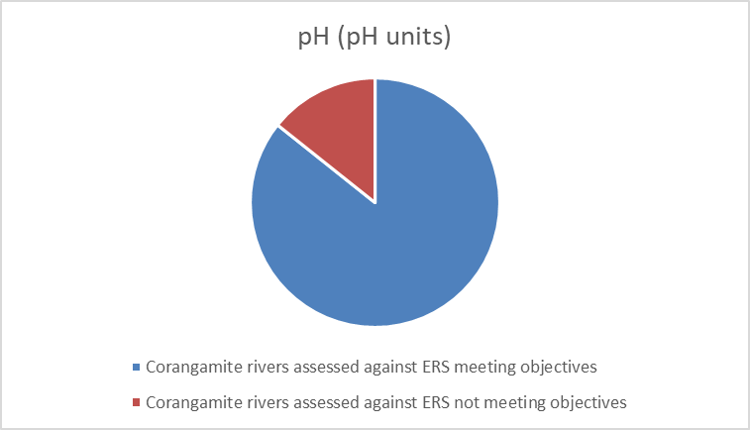
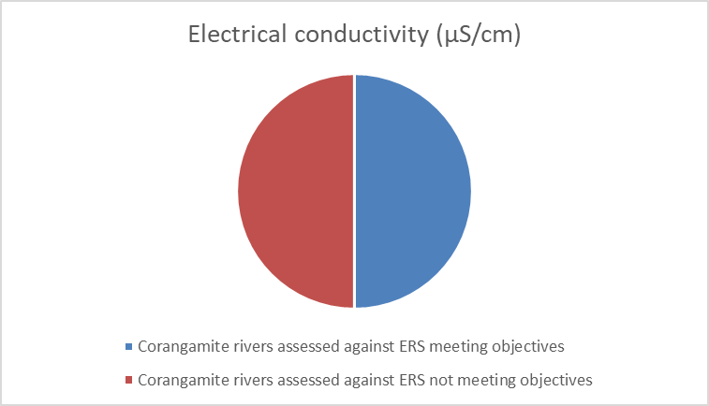
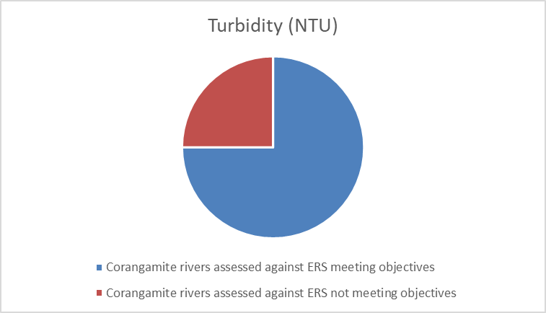
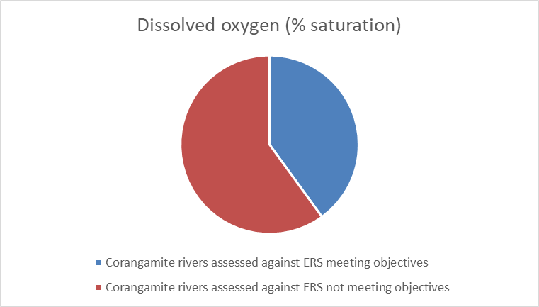
Source Waterwatch database

2022-23 assessment - TREND Neutral | Rolling five year assessment - TREND Neutral

LAND Condition and Management Rating - Moderate
The condition and management rating for land is moderate. Four key indicators that show a mix of trends have been used to determine a five-year rolling trend of concerned. 22/23 was a relatively wet year, continuing a period of higher-than-average rainfall, this leads to a neutral annual trend in exposed soil, and positive annual trend in rainfall. The rolling five-year trend across the indicators shows a mix of results, with a concerned trend in both exposed soil and land use change over time, neutral trend in rainfall, and positive trend in agricultural commodities.
Programs supporting sustainable agricultural practices and land stewardship continue to engage with property owners across the region, however the long-term trends in land use change particularly significant increases in dry land cropping and decreases in native vegetation are significant challenges to land health.
Rationale for assessment
- The area of exposed soil within the Corangamite region is largely a function of climatic conditions along with land use; annual crops require sowing each year with periods of fallow in between harvest and sowing the next crop. 2022-23 was a relatively wet year with periods of higher than average rainfall. For the Corangamite region, typically the areas of greatest exposed soil are on the land use types grazing on modified pasture and dryland cropping. Trends indicate a decrease in the area of exposed soil, most likely due to wet conditions and associated increased plant growth (especially over summer).
- Landuse change over time data shows decreases in native vegetation types, and significant increase in dryland cropping and hardwood plantations. Increases in urban and built environments contribute to an increase in extent of hard surfaces leading to impacts on waterways with increased stormwater. This is particularly concerning in coastal areas with saltwater systems getting an influx of fresh water.
- The Corangamite CMA works in partnership with key stakeholders in the region (Landcare, Agriculture Victoria, WestVic Dairy, Otway Agro Forestry Network, and Southern Farming Systems). Funding support is provided by Agriculture Victoria, Meat & Livestock Australia, the Australian and State Government to work with landholders to manage their land sustainably and protect land and water resources in the catchment primarily from the threats of soil degradation processes. Agricultural commodities in the region continue to perform strongly.
- The opportunity to engage landowners in sustainable agriculture events and projects has remained steady in this current financial year due to the further implementation of both the Australian Government’s Regional Land Partnership program, and the Our Catchments Our Communities funded Small Block Big Dreams project.

Land indicators used in the assessment

Percentage of exposed soils
This indicator enables the reporting of percentages of exposed soil in public and private land.
Vegetation groundcover varies between seasons, is based on changes in land management and is highly variable between years. Groundcover is a sub-component of land cover and can be used to infer land management practices. Ground cover is defined as the vegetation (living and dead), biological crusts and stone that is in contact with the soil surface.
The level and type of ground cover is important for land management as it plays an important role in:
- protecting valuable soil resources from erosion
- nutrient cycling
- maintaining biodiversity.
The amount and distribution of ground cover can change in response to climate, land or soil type and land management, especially grazing intensity, cultivation and burning. The figure below illustrates the percentage of exposed soil over time as the surrogate for groundcover

Source- Australia's Environment Explorer (ausenv.online)

2022-23 assessment - TREND neutral | Rolling five year assessment - TREND concerned

Annual Rainfall
This indicator looks at the annual Rainfall. Rainfall and the timing of rainfall will impact on agricultural production, opportunities to maximise environmental flow releases and water quality.
The Corangamite region typically experiences rainfall that increases towards the coast and decreases further north, especially through the winter months, due to natural rain shadow effects.
The figure below shows the annual rainfall in the Corangamite Region (as an average across the region) and indicates that across the region rainfall was higher than the previous years, with a wet winter followed by a wet summer, followed by again a wet autumn and early winter.

Source Australia's Environment Explorer (ausenv.online)
2022-23 assessment - TREND positive | Rolling five year assessment - TREND neutral

Agricultural commodities
This indicator aims to provide estimates of the type and gross value of agriculture commodities in the Corangamite Region.
The contribution of agriculture to the regional economy has been strong over the past three years. In 2020-21:
- Total gross value of agricultural commodities in the Corangamite region was more than $1,634 million (M)
- Gross value of crops was more than $347 M, with broad acre crops (wheat) having the greatest contribution
- Total gross value of livestock products was more than $635 M, including more than $531 M for milk products
- Livestock slaughtered (meat production) and other disposals was more than $651 M, to which cattle and calves contributed more than $315 M.

Source- ABS value of Agricultural commodities produced Australia
Note- Data not available for 2021-22 due to lower than required responses to produce a full set of regional agriculture statistics.

2022-23 assessment – TREND N/A | Rolling five year assessment - Positive

Land use change over time
This indicator provides estimates of the current and overall rate of change in the extent and spatial distribution of land use classes on public and private land in Corangamite Region.
Over the period between 2015-19, non-native pasture was the dominant land cover in the Corangamite region, compromising 61% of the total area (ha) covered among the classes analysed (not including water and wetland categories).

Native trees (22%) native grass herb (5%) and dryland cropping (3%) are the other most common land covers. The remaining land cover types account for only 7% of land cover. Over the time series (see figure below) there have been significant (100% or more) increases in dryland cropping and hardwood plantations.

Urban cover and Built-up cover (22%), which is associated with commercial or industrial development have both also increased. Increases in urban and build environments contribute to an increase in extent of hard surfaces leading to impacts on waterways with increased stormwater. This is particularly concerning in coastal areas with saltwater systems getting an influx of fresh water.

Percentage change in land cover classes- Corangamite Region 1985-2019

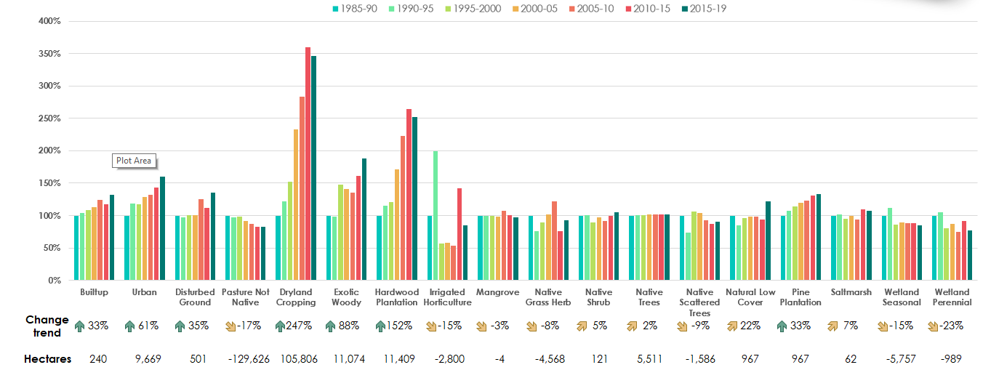

Source Victorian Land Cover Time Series (DEECA)

2022-23 assessment - TREND N/A | Rolling five year assessment - TREND Concerned

COAST Condition and Management Rating - Moderate
The condition and management rating for community is moderate. Two key indicators have been used to determine a rolling five-year trend of neutral. There is positive trend in area of salt marsh protection and neutral trend in estuarine water quality leading to a neutral annual trend.
While there are management practices in place and estuary water quality was stable and there was an increase in saltmarsh, the coasts and estuaries of the region face significant challenges associated with the threats posed by climate change as well as population, land-use and developmental pressures on the natural values of these assets. Critical water health issues (acidity, stormwater inflows, and cyanobacteria blooms) persist in several estuaries in the region.

Rationale for assessment:
- Water quality in the estuaries declined this year, largely due to local blue green algae events. These incidents have a negative impact on turbidity results. Various factors can change the percentage of dissolved oxygen within an estuary including temperature and upper catchment flows.
- The area of saltmarsh under protection remains relatively stable compared to previous years; however, saltmarsh is particularly vulnerable to continued sea level rise forcing it inland further and land use pressures stopping migration, thus squeezing saltmarsh on the coastal fringe. Fresh water inflows, especially from storm water has had impact in some locations, especially the Karaaf wetlands.
- The Corangamite CMA continues to work with key stakeholders and the community regarding estuary management that supports environmental outcomes, as well as asset protection. There remain some tensions associated with the artificial openings across some estuaries.
- There has been unprecedented amount of artificial estuary openings (AEO) in the last few years (22-26 annually in the last 3 years), to protect public and private assets. It is not possible to mitigate the majority of risks and consequences associated with AEO’s, particularly impacts on endangered and threatened estuarine species.
- A number of estuaries in the region have critical and complex issues, including acidity and extremely low biodiversity in the Anglesea River estuary, emerging acidity issues at the Aire River, and Cyanobacteria blooms in the Curdies River estuary.
- The Marine and Coastal Strategy 2022 outlines a number of actions that are aimed at improving the condition of the coast, adapting to the impacts of climate change and supporting sustainable use and development.
- The formation of the Great Ocean Road Coasts and Park Authority sets out management responsibilities for public land and marine waters and is a foundation for improved coastal management.
- Bellarine Great Ocean Road Dunecare Initiative has invested in coastal management projects on-ground over past 3 years.
Coast and estuary indicators used in the assessment

Saltmarsh under management
This indicator looks at area of saltmarsh under contract.
There is approximately 3,766 ha of saltmarsh in the Corangamite Region, this is predominantly coastal saltmarsh, although here are some areas of saltmarsh within the Western District Lakes complex.
The data below presents the area under contract for saltmarsh protection (all coastal saltmarsh) as a result of programs delivered by the CMA, this year there has been a large increase in area under contract with new contracts with Parks Vic for a large onground works program.

Protection includes onground works such as pest plant and animal control and grazing management through fencing and periodic changes to grazing managed with landholders.

An assessment of sea level rise impacts to saltmarsh in Swan Bay and the migration potential of saltmarsh in this system has been undertaken.

 | 2016-17 | 2017-18 | 2018-19 | 2020-21 | 2020-21 | 2021-22 | 2022-23
Saltmarsh protection (ha under contract) | 711 | 717 | 235 | 514 | 475 | 1,888 | 1,188

Source Corangamite CMA
2021-22 assessment - TREND Positive | Rolling five year assessment - TREND neutral

Water Quality (Estuarine)
This indicator compares the EstuaryWatch data for 7 estuaries against the Victorian Environment Reference Standards
2022/23 was a wet year, leading to increased river inflows taking with it an increased load of sediment and nutrient into the region’s estuaries causing issues around BGA and water quality. Presence of a blue green algae bloom at Curdies River estuary will have an impact on water quality parameters including turbidity and dissolved oxygen levels. Low pH persists in the Anglesea River estuary, and there are low pH issues emerging in the Aire River estuary.

Corangamite estuaries assessed against ERS meeting objectives for TOP turbidity 28%
Corangamite estuaries assessed against ERS meeting objectives for TOP dissolved oxygen (% sat) 43%
Corangamite estuaries assessed against ERS meeting objectives for BOTTOM dissolved oxygen (% sat) 71%

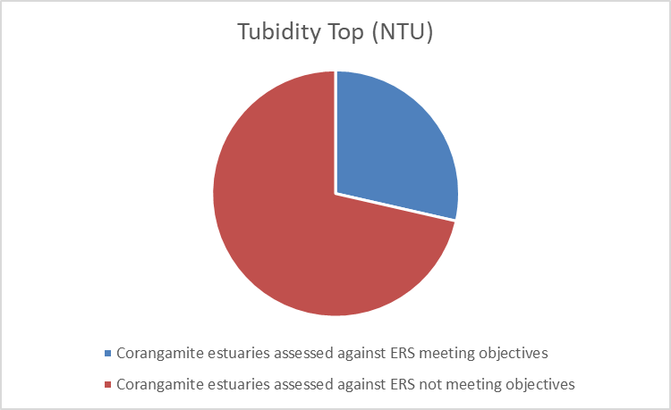
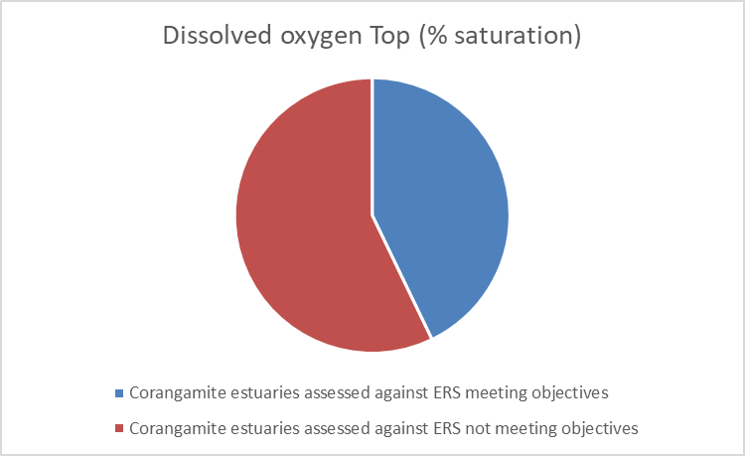
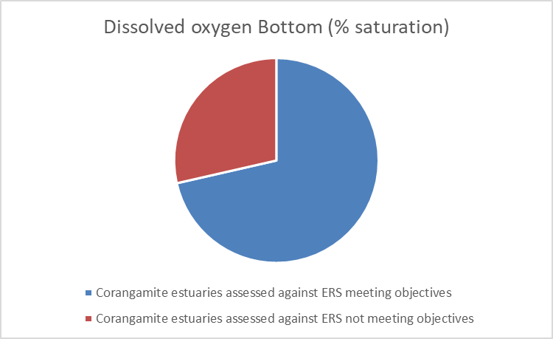

Source EstuaryWatch database

2022-23 assessment - TREND neutral | Rolling five year assessment - TREND neutral

BIODIVERSITY Condition and Management Rating - Poor
The condition and management rating for biodiversity is poor. Four key indicators have been used to determine a rolling five-year trend of concerned. There has been notable increase in area of pest predator and herbivore control and weed control. No notable change has been observed in the extent of native vegetation or the area of permanent protection in the region- leading to a neutral annual trend.

Species decline is still a critical challenge facing biodiversity in the Corangamite Region predominantly due to pressures such as introduced animal and plant species and land clearing being exacerbated by the increasing trends of urban encroachment, habitat fragmentation, climate variability and the spread of invasive species and diseases. Whilst there is a positive trend in the extent of management interventions being delivered, there currently isn’t the ability to clearly determine the impact this is having on the feral animal populations in the region. The extent of interventions is still very minor in comparison to the extent of the problem.

Rationale for assessment:
- Introduced animal and plant species and land clearing, along with increasing trends of urban encroachment, habitat fragmentation, climate variability and the spread of invasive species and diseases, are all placing intense pressure on biodiversity in the region.
- Threatened species and biodiversity projects are delivering positive outcomes, however the impact is small in the face of the extent of threats to biodiversity in the region.
- There have been increases in knowledge and research delivered through the Wild Otways project providing valuable insights that will assist future biodiversity projects. This project has determined that the overall trend for threatened small mammals is a decline in both numbers and distribution across fragmented habitat refuges.
- Specific projects such as the Orange-bellied parrot protection, Grassy Eucalypt Woodlands, and Phytophthora management program are delivering positive outcomes for threatened species and biodiversity protection.
- The approval of a three year off label permit for phosphite to combat the plant pathogen Phytophthora cinnamomi has led to both aerial and hand spraying to slow the spread of the disease and protect biodiversity in heathlands and heathy woodlands of the Otway Ranges.
- Remnant and revegetation sites continue to be actively managed under the management agreements of past programs.
- Concerted effort is still required under future programs to engage those landholders who have either been unwilling or unable to engage in these programs in the past. The Corangamite CMA is exploring opportunities through social benchmarking studies.

Biodiversity indicators used in the assessment

Extent of native vegetation
This indicator aims to provide estimates of the current and previous extent and spatial distribution of native vegetation on public and private land in the Corangamite Region.
Most of the current losses of native vegetation in the region may be attributed to loss in condition (80%) with 20% being removed through clearing (VEAC, 2011). The survival of threatened flora and fauna and ecological communities depends a great deal on the health of native vegetation, and the condition of other important habitats that are threatened by human activities and vulnerable to climate change stress.
The figure below shows land cover changes between 1985 to 2019 in the extent cover of native grasses, shrubs, trees, scattered trees, and natural low cover. During this time there has been a minor declining change trend for both native grass herb (-8%), and native scattered trees (-9%), and a minor positive change trend for native trees (2%), Native shrubs (5%), and natural low cover (22%).
Percentage change in native cover classes- Corangamite Region 1985-2019
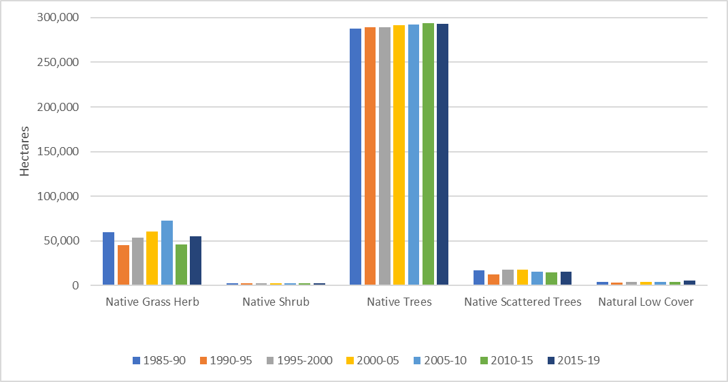

Source- Victorian Land Cover Time Series (DEECA)
2022-23 assessment – N/A | Rolling five year assessment – TREND neutral

Area (ha) of pest herbivore and predator control
This indicator provides information on the area treated for pest control, including herbivore and predator control, under CMAs initiatives.
Invasive pest animals are one of the main threats to biodiversity, impacting environmental and socio-economic systems.

There are increasing populations of invasive animals such as European carp in waterways across the region. After three years of high rainfall and favourable conditions feral deer, cats, foxes, rabbits and pigs have grown in number, particularly in the Otway Ranges.

In 2022-23, Corangamite CMA initiatives resulted in 4,076ha of pest predator and herbivore (feral animal) control, this significant increase is due to the increase in investment through the Wild Otways Initiative.

Whilst there is a positive trend in the extent of feral animal control being delivered through management interventions, there currently isn’t the ability to clearly determine the impact this is having on the feral animal populations in the region. The extent of interventions is still very minor in comparison to the extent of the problem. For these reasons, the annual trend has been moderated to neutral and the rolling 5 year trend has been moderated to concerned.

Source- Corangamite CMA

2022-23 assessment - TREND Neural | Rolling five year assessment - TREND Concerned

Area (ha) of weed control
This indicator provides information on the area treated for weeds under CMAs initiatives.
Environmental weeds significantly impact the quality of remnant native vegetation and habitat for fauna. Weeds also decrease agricultural land productivity, impact recreational opportunities, and pose challenges to the management of pest animals that benefit from the shelter provided by them.

Invasive plants such as Glyceria and Willow are causing problems in waterways across the region.

The increased spread of weeds across the landscape in the past decade is a rising concern among the community and land managers in the region, particularly with weather conditions over the past three years being favourable for weed invasions to take hold.

In 2022-23, Corangamite CMA initiatives resulted in 5,160ha of weed control across the region. Whilst there is a positive trend in the extent of weed control being delivered through management interventions, there currently isn’t the ability to clearly determine the impact this is having on the overall extent of weeds in the region. The extent of interventions is still very minor in comparison to the extent of the problem. For these reasons, the annual trend has been moderated to neutral and the rolling 5 year trend has been moderated to concerned.

*Ha reported are for total area where weed control activities have been delivered, noting actual weed control interventions will only have occurred on a small percentage of these area

Source- Corangamite CMA

2022-23 assessment – TREND Neutral | Rolling five year assessment – TREND Concerned

Area (ha) of permanent protection
This indicator provides information on the number, extent and distribution of government, Indigenous and privately protected areas in the Corangamite Region.
The Region has extensive National and State Park in the Otway Ranges, area of land protected is currently remaining stable.

Protection Type | Number of protected areas | Total area (ha) | Proportion of total protected areas in region (%)
National Park | 3 | 115,009 | 79.2%
State Park | 2 | 4,323 | 3.0%
Others (Public land)* | 149 | 25,403 | 17.5%
Conservation Covenants | 6 | 89# | 0.1%
Others (Private land)* | 7 | 400 | 0.3%
Total |  | 145,136 | 100%
Others (Public land)* - Conservation Park, Heritage Park, Nature Feature Reserves, Nature Conservation Reserves, Reference Area
Others (Private land)* - Private Nature Reserve
Public Land* - based on all public land as per PLM25

Public land compromises 21% of the Corangamite Region, which includes areas of permanent protection as part of a National Park, State Park or other public lands (115,009 ha). Additionally, 89 ha of private land is protected by conservation covenants

Source- Collaborative Australian Protected Areas database and Trust for Nature records
2022-23 assessment – TREND Neutral | Rolling five year assessment – TREND Neutral

COMMUNITY Condition and Management Rating - Good
The condition and management rating for community is good. Four key indicators have been used to show a positive annual and positive rolling five-year trend. There has been an increase in both Traditional Owner partnerships and total number of Catchment Partnerships Agreement members. The total number of partnerships continues to increase in number compared to last year. The Landcare health survey continues to reflect that most groups in the Corangamite region are moving forward or above. Citizen Science volunteer numbers have increased this year after a decline over the past five years (largely due to COVID restrictions).

Rationale for assessment:
- The Corangamite CMA continues to focus on strengthening partnerships with both Traditional Owner groups in the region through the Eastern Maar Aboriginal Corporation and Wadawurrung Traditional Owners Aboriginal Corporation. This has been formalised this year through the signing of a Partnership Agreement with Wadawurrung Traditional Owners Aboriginal Corporation. The Corangamite CMA, Glenelg Hopkins CMA and Eastern Maar Aboriginal Corporation signed an agreement to employ a CMA Partnerships Officer embedded in Eastern Maar.
- The Corangamite CMA continues to increase the number of partnerships with a range of stakeholders. Key examples include the partnership with Zoos Victoria and DEECA to deliver the Orange-bellied parrot mainland release trials, the cross-tenure partnership between Corangamite CMA, Landcare, Conservation Ecology Centre, DEECA, and Parks Vic to deliver the Wild Otways Initiative, and the partnership with Agnico Eagle Australia and NCCMA to deliver River Detectives 2023
- The region increased the Catchment Partnership Agreement from 17 to 19 regional NRM government agencies. This partnership provides a strong foundation for delivering a coordinated approach to responding to community driven local? priorities in natural resources management.
- Corangamite CMA actively participates in several key forums for the region. These include three Integrated Water Manager Forums that resulted in the development of Strategic Decision Statements supported by priority projects: G21 Alliance and the Barwon South West Climate Alliance.
- Each year, Landcare and other community groups who complete a Victorian Landcare Grant Application are invited to complete a Group Health Survey, which records group perceptions of their current health and activity levels. This year’s group health survey results are stable, with numbers of groups reporting the moving forward category or slightly increasing, and a very small reduction in the number of groups reporting they are just hanging on.
- The Regional Agriculture Landcare Facilitator (RALF) continues to be active in the region, working closely across a diversity of CMA and external programs to help facilitate improvement of knowledge and skills.
Community indicators used in the assessment
Number of formal partnership agreements
This indicator provides information on the number of formal partnerships established, modified, or maintained between organisations and individuals, under CMAs initiatives.
There is a growing recognition of Traditional Owners’/First Nations Peoples’ self-determination, their rights and their role in NRM. There is also a growing commitment among Governments to elevate Traditional Owners/First Nations Peoples’ role in the policy, planning and management of Country.

Traditional Owners/First Nations Peoples take a holistic, adaptive approach to management of Country. Government, as a natural resource manager, has taken steps to bridge different planning, governance and management arrangements through joint and co-management of some areas of public land, developing partnerships with Traditional Owners/First Nations Peoples and integrating Traditional Owners/First Nations Peoples, cultural values, practices, objectives and knowledge (where permission has been granted) into NRM.

In 2022/23 a formal partnership agreement was signed between Wadawurrung Aboriginal Traditional Owners Corporation and the Corangamite CMA. The Corangamite CMA, Glenelg Hopkins CMA and Eastern Maar Aboriginal Corporation signed an agreement to employ a CMA Partnerships Officer embedded in Eastern Maar.

Both Eastern Maar Aboriginal Corporation and Wadawurrung Aboriginal Traditional Owners Corporations are signatories to the Corangamite Catchment Partnership Agreement and have been involved throughout the implementation of the RCS. The Corangamite CMA is committed to continuing to work with Traditional Owners/First Nations Peoples to enable the application of their knowledge and practices in NRM.

Both the Corangamite Shire and Great Ocean Road Coast and Parks Authority have joined the Corangamite Catchment Partnership.

Memorandums of Understanding have been maintained with Barwon Water, Central Highlands Water and Wannon water

Source- Corangamite CMA

2022-23 assessment - TREND Positive | Rolling five year assessment - TREND Neutral

Number of partnerships
This indicator provides information on the number of formal partnerships established, modified, or maintained between organisations and individuals, under CMAs initiatives.
Fostering and maintaining strong partnerships is a focus across all Corangamite CMA programs. The data below shows a positive trend in the number of partnerships.

Source- Corangamite CMA

2022-23 assessment - TREND neutral | Rolling five year assessment - TREND Positive

Community volunteering (Landcare / community NRM Groups – Group Health Score)
This indicator provides estimates of Landcare volunteering contributions and commitment to environmental conservation and sustainable development in Victoria.
Each year, Landcare groups are invited to complete a Group Health Survey, which records group perceptions of their current health and activity levels; see figure below.

Survey results for 2022-23 are positive and demonstrate that we have healthy groups in Corangamite, with the majority (90%) reporting themselves as in the ‘moving forward’ category or above. A small number of groups (2%) have emerged in the ‘just hanging on’ and 8% of respondents say they are struggling along.

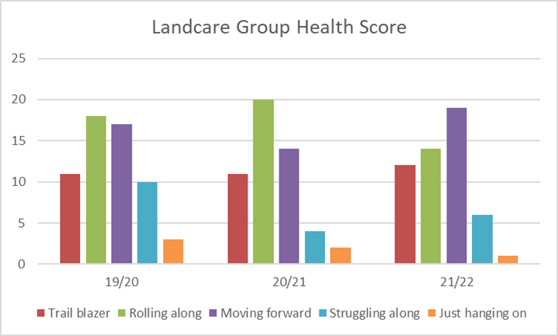
Source- Landcare Group Health Survey

2022-23 assessment – TREND neutral | Rolling five year assessment – TREND Positive

Number of Citizen Science volunteers
This indicator provides information on the number volunteers participating in the WaterWatch and EstuaryWatch programs.
This year there was an increase in volunteer numbers for the WaterWatch and EstuaryWatch programs following three years of declining volunteer numbers across.

The rolling five year trend is assessed as negative due to the continuous decline in volunteer numbers, largely due to COVID restrictions impacting on volunteers being able to participate in the programs.

2018-2019 | 2019-2020 | 2020-2021 | 2021-2022 | 2022-2023
140 | 123 | 107 | 98 | 102

Source- Corangamite CMA

2022-23 assessment – TREND positive | Rolling five year assessment – TREND negative

Corangamite CMA Approach to Catchment Condition and Management Reporting

Corangamite CMA reports annually on condition and management through its Annual Report. Catchment condition and management reporting is structured to align with the state-wide Regional Catchment Strategy outcomes framework which consists of five themes and a set of agreed indicators.

Corangamite CMA also includes additional regional indicators and contextual evidence to support trend and condition ratings and describe changes in the operating environment (Table below).

A set of rubrics were developed in 2018 to provide a transparent approach to assigning trend ratings for each indicator, linking the evidence and assessment. Rubrics were developed through a consultative process with Corangamite CMA technical staff. The rubrics were reviewed in 2022 to bring them in line with the statewide outcome framework indicators introduced this same year.

It should be noted on the basis of the limitation of the information to inform catchment condition and management within a Corporate Annual Report, the Corangamite CMA use technical staff to inform this process.

The process for developing the annual condition and management reports and assigning ratings is as follows:

- Corangamite CMA staff compile data for condition and management indicators relevant to their area of work. Note that not all indicators are available in a given year (e.g. LandCover data is only available periodically).

- Additional supporting evidence is collated (rainfall, socio-political factors, management activity / outputs).

- A draft report is prepared, and each theme peer reviewed by a team of content expert Corangamite CMA staff. These staff contribute data and assist in moderating a collective assessment based on the rubrics for each theme. This approach was initially delivered via a face to face internal workshop, but from 2020 this was transitioned to an individual review and assessment that were collectively bought together and synthesised into the final report.

- Annual condition uses a rubric and for the last 5 year trend a subjective assessment is made and looking for movement in any particular direction, noting 2020 -2021 was the first year the trend assessment was included.

- For the overall trend rating (at theme level) the ratings are weighed up across indicators within the theme with consideration to the number of ratings in each category.

- The Board endorses the catchment condition and management report, and the summary table is published in the Corporate Annual Report (the full catchment conditional and management report is published on the Corangamite Regional Catchment Strategy website).

Overview of CCMA condition and management themes and indicators
State-wide outcomes framework themes | Indicators used in CCMA report (bold indicates outcomes framework indicator) | Notes on alignment with state-wide outcomes framework
Biodiversity | Extent of Native vegetation (ha)  Area of pest herbivore and area of pest predator control (ha)  Area of weed control (ha)  Area of permanent protection (ha)
Water | Total river inflow (mm)  Extent and condition of wetlands (ha)  Groundwater levels  Water quality  Extent of protected or improved riparian land (ha)  Flow compliance | Additional indicators reported – flow compliance, water quality (riverine – pH, EC, turbidity, DO)
Land | Gross value of agricultural commodities ($)  Amount and change over time of landuse (%)  % exposed soils  Annual rainfall | Annual rainfall included as a regional indicator
Coast and marine | Saltmarsh protection (ha)  Water quality estuarine | Additional regional indicators reported (aligned to state-wide e.g. extent of saltmarsh using landcover data and estuary water quality using report cards)
Community | Landcare/Community NRM Groups Health Score  No. formal partnership agreements for planning and management between Traditional Owners and key NRM agencies  No. partnerships
Integrated Catchment Management |  | Reported under community (no. partnerships)

